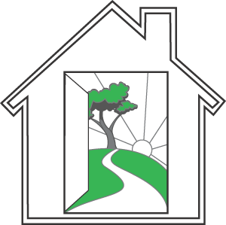
Mental Health Association of San Mateo County
2686 Spring St., Redwood City, CA 94063

APPLICATION TO BE A COMMUNITY FRIEND

A Community Friend is a mental health client who is paid to support a peer to become more active in the community. A Community Friend calls the peer and invites them to enjoy activities together. Community Friends schedule and keep appointments, work with an activity budget, maintain records, write legibly, complete paperwork in a timely manner, have a presentable appearance, and work with little supervision. Community Friends work on a contract basis from 8 to 24 hours per month. The rate of pay is $10.00 per hour.

Print Name:

Address:

City/Zip: Phone: Date

Treatment Team:______________________________________________________________________

Return this form by mail to MHA, 2686 Spring St., Redwood City, CA 94063
Att: Angela Bruno-Castro or by fax to (510) 879-0354. For further information call (650) 257-8823.

Please check activities below that best suit you and are comfortable for you to do with a peer.

Visiting museums Attending sporting events

Bingo Golf

Art & Craft Fairs Computers

Shopping Listening to music

Bowling Swimming

Dining out Reading

Exercise/Physical fitness Doing crafts

Going to the movies Getting a manicure/pedicure

Going to the park or beach Chess

Dancing Gardening

Plays/Theater Pool/Billiards

Cooking Trips to San Francisco or San Jose

Other

